Assignment K means Image Dataset

Table of Contents

Observation for Each Image 2

Python Code 2

**We can see that as number of clusters are increasing, more clarity in clustering can be seen.**

**Euclidian distance matric will give clearer and better results in clustering as compare to chess board distance and city block distance.**

Name: - Vikash Singh

Roll No: - 100150

VIT Bhopal

# 

# Observation for “1.gif”

**Input Image: - “1.gif”**

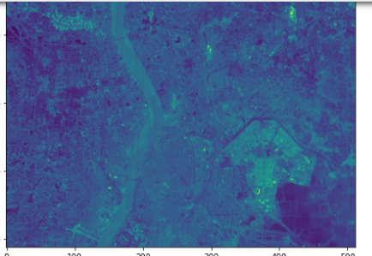

**Clustering Using Euclidian distance** (default method of k means):-

K = no of clusters = 5

# 

K = no of clusters = 20

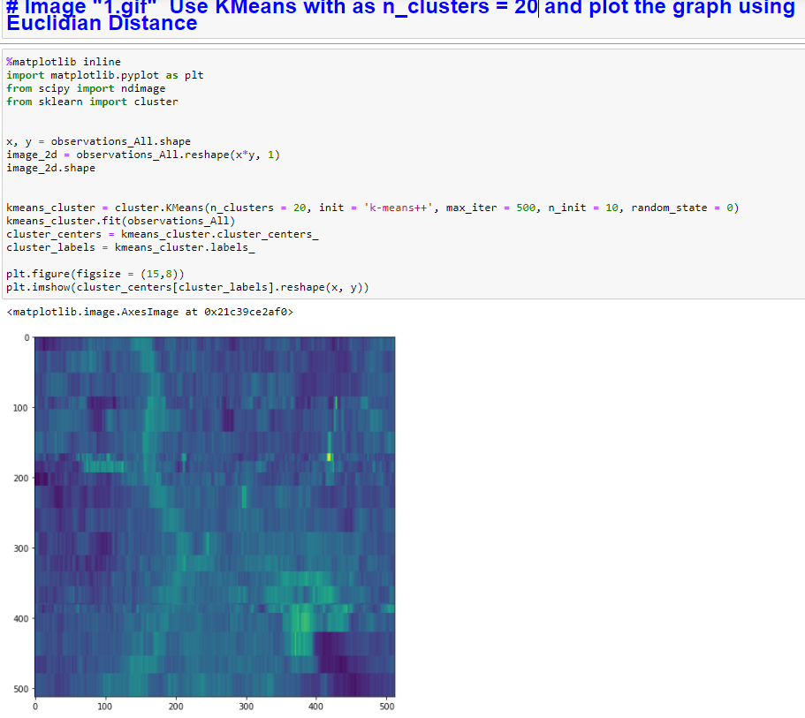

K = no of clusters = 50

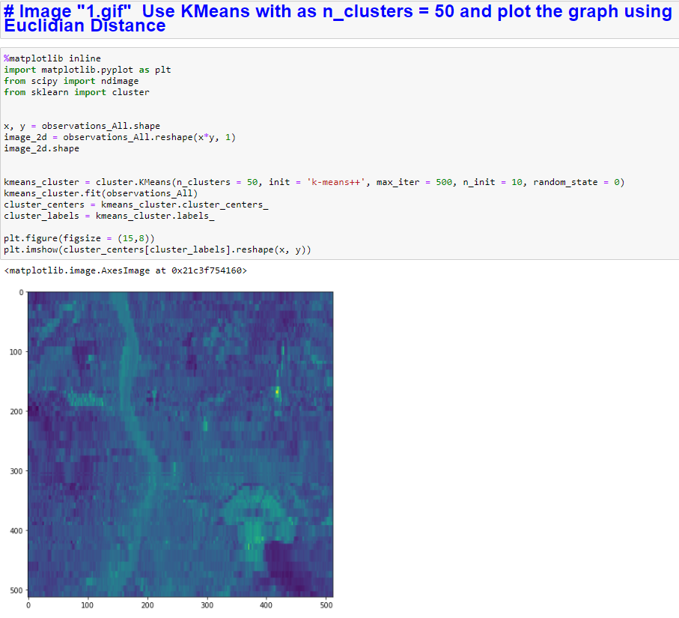

# Observation for “2.gif”

**Input Image: - “2.gif”**

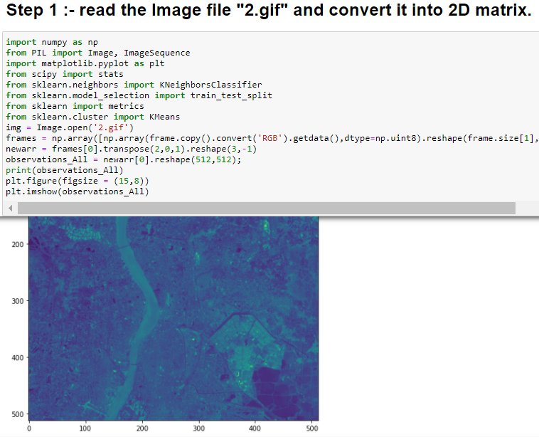

**Clustering Using Euclidian distance** (default method of k means):-

K = no of clusters = 5

# 

K = no of clusters = 20

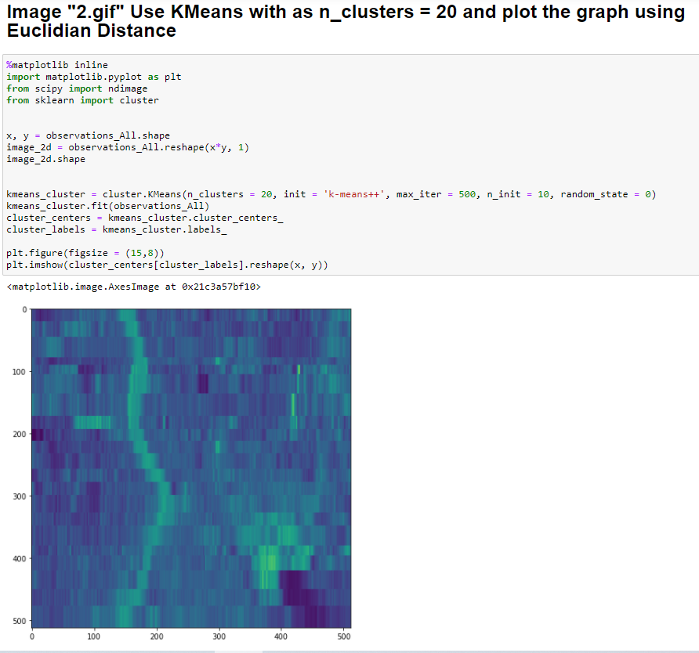

K = no of clusters = 50

# 

# Observation for “3.gif”

**Input Image: - “3.gif”**

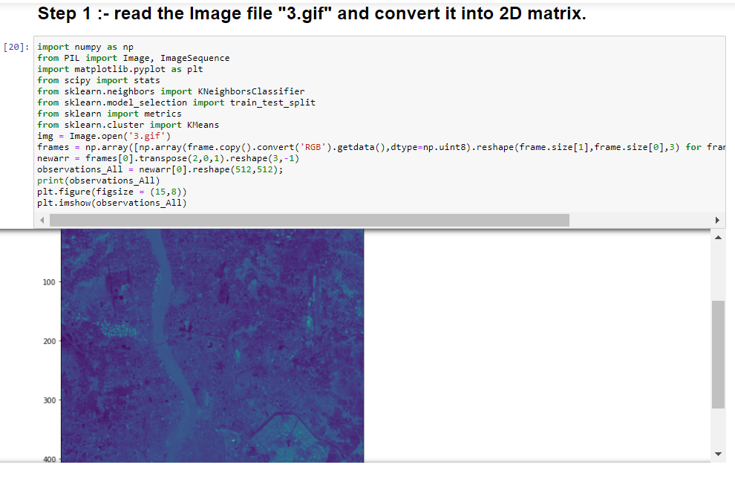

**Clustering Using Euclidian distance** (default method of k means):-

K = no of clusters = 5

# 

K = no of clusters = 20

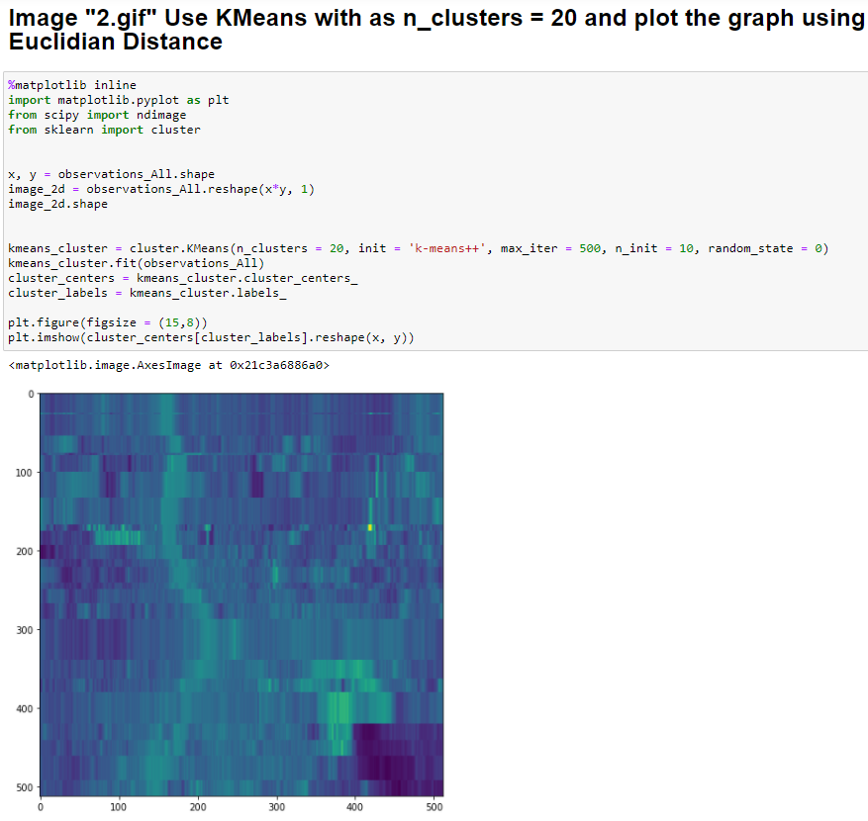

K = no of clusters = 30

# 

# Observation for “4.gif”

**Input Image: - “4.gif”**

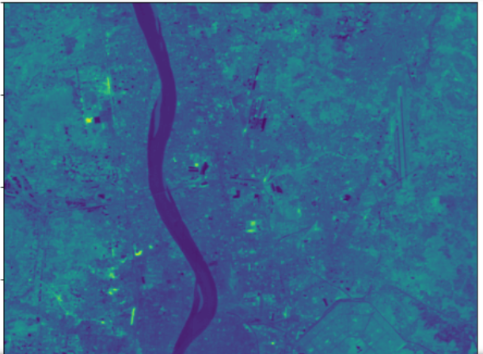

**Clustering Using Euclidian distance** (default method of k means):-

K = no of clusters = 5

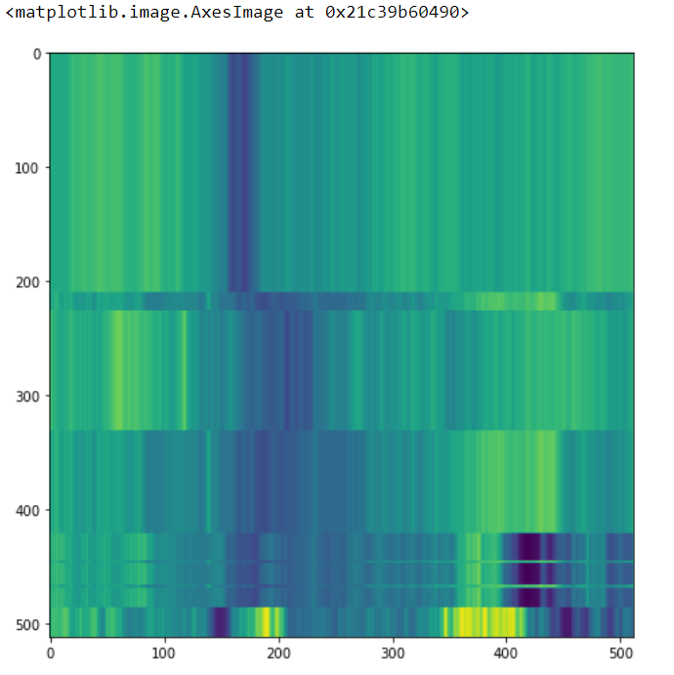

K = no of clusters = 10

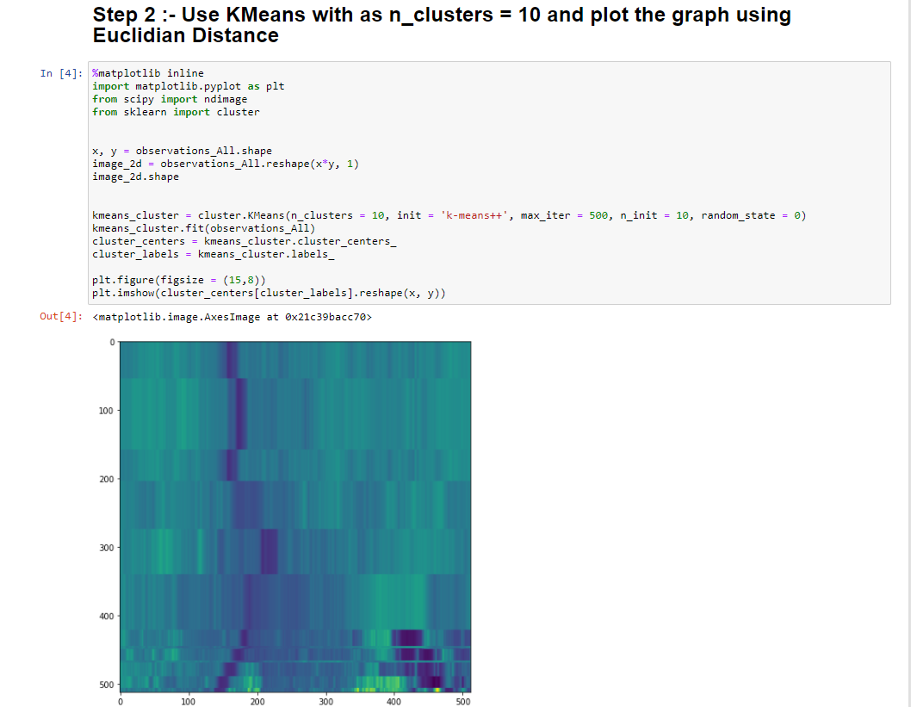

K = no of clusters = 20

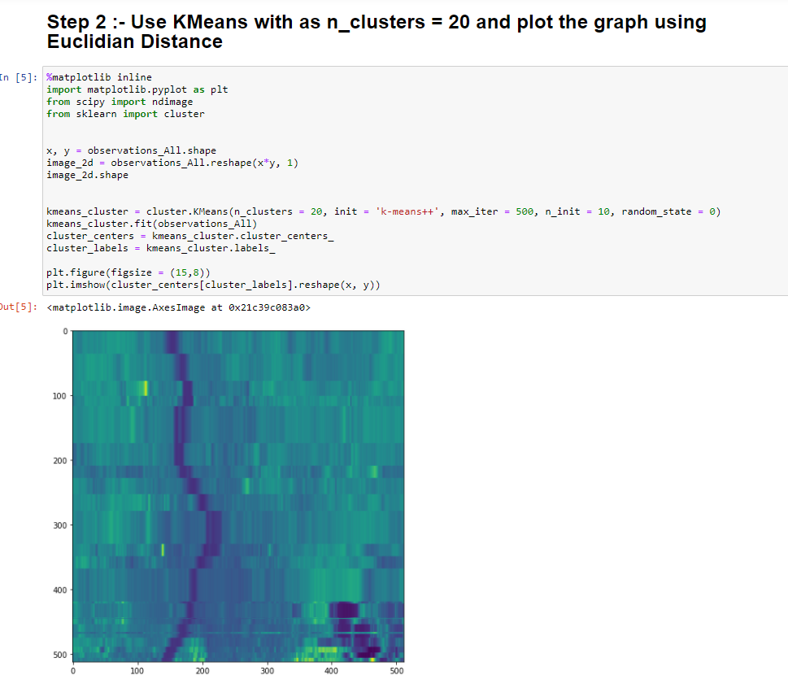

K = no of clusters = 30

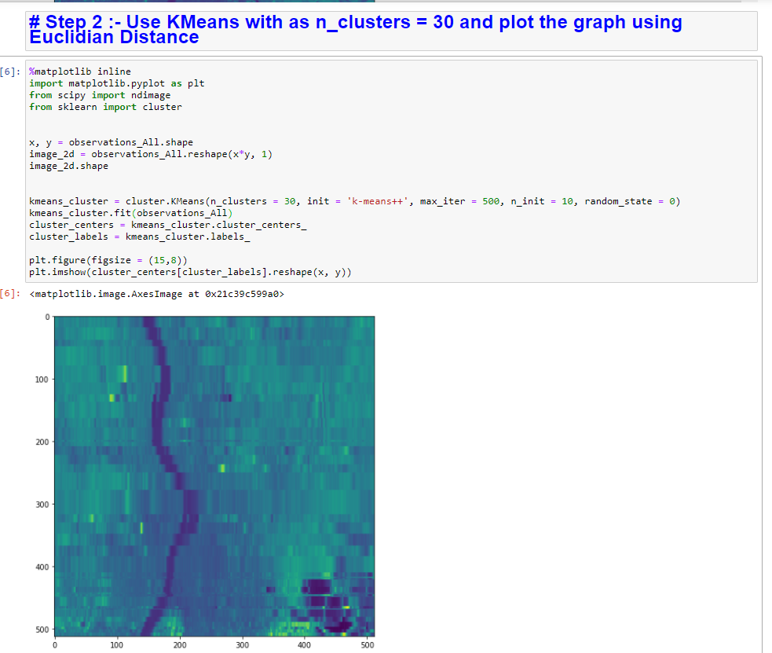

**We can see that as number of clusters are increasing, more clarity in classification can be seen.**

# Python Code

